Från början fanns även bilder för varje ämne utsatt I texten men då upphovsrätten förbjuder mig att ta med dessa så blev detta kvar!

Astronomy

I’ve had some problems whit choosing a subject, but after some hours of looking at the stars for an answer I was brought an idea!
Why don’t write about astronomy?
I find it very interesting and I would just be happy if I had a chance to learn some more about it! Exactly what is cosmos? How does a star die?
So I started to make a research on the internet. When I had all of the facts I needed I started to work whit this essay. I wanted every single word in its right position so I had to check every thing many times to be sure that every thing is where it’s supposed to be.
So what more can I say? Just read and enjoy!

Astronomy is a great subject which contains many smaller subjects, such as:
- Asteroids
- Comets
- Nebulaes
- Galaxies
- Cosmos. And actually everything that exist in it!

We will start whit some history.
One of the strangest things on earth and probably one of the first things that are connected to astronomy is Stonehenge:

This is a simulation of the classical Stonehenge which the most of us is thinking about when we here the word Stonehenge. But there were many different formations from different places on the timeline.
The oldest one is from year 3150 b.ch.
The one on the picture above is called the “Saracen circle” and it is dated to 2600 b.ch.
The stones which is used to build it is between 4.6 to 7.3 meters tall! And all of them were given their shape on the place where they stands, which means that when they transported them they were much larger! How did they do it? And who did it?
Other things that wakes the fantasy is why some of the stones got a lot of very hard work behind them while some “only” is shaped and pulled to the right positions...
But what did they do whit this great peace of work? We have theories which tells that when the sun and the moon and also some stars felled between the stones the most knowledge peoples could tell the date and probably a lot of other things which we never will now about. Scary, isn’t it?
So what more did people know about astronomy in the ancient?
Well we know that the Mayan could calculate how many days it was in a year, but how they did it is a complete mystery for us.

But now! Astronomy in our time!
I have planed everything like this: we will start whit the smallest things out in cosmos and aim for larger things! So, first out: Black holes!

Even thow black holes is one of our latest discovers in cosmos we already know so much about them that we for example got a theory on how we could be able to visit one of the most long distant places out in the cosmos.
But first the basics.
You probably already know that black holes are some kind of celestial bodies*
which “sucks” up anything in its territory. Including light!
But to understand how it works we need to know how they are being created.
It all starts whit a star which is at least three times bigger than our own sun.
When smaller stars dies (when they burned all there fuel) they have power enough to keep the inside pressure so that they keep there size but this larger stars don’t got enough power to resist the outside pressure so they will be pressed to an insane small size. If the star had a size on ten times of our sun the black hole would get an size of 30 kilometres from one side through the other.
But what that makes black holes to a disaster is that all of the stars gravity will be compressed to fit the new size of the black hole. So think like this: If your body mass had a weight of 60 kilos on the star you would have a weight of many millions of tons on the black hole! You would be compressed to nothing!
Now the even more interesting is that some of the holes can turn there inside out. And when they do that there is, just fore a short time, a kind of connection between it and some other place in space and time! This connection is like a tunnel between the places. And the thing that makes this “tunnels” interesting is that we probably sometime will be able to travel thro them!
That’s right, we’ve discovered that if we put a large metal ball in both openings it probably will be so stabile so that it’ll be possible to travel trough it. And the speed that we would contain is bigger than possible!
Even Albert Einstein had his theories abut this. But he was not so positive…
He made the mathematic term “E=mc2”, which means that if a material object is close to the speed of the light it will be a lot heavier, and when an object gets as much gravity as it would get the time would slow down, or every thing around would speed up. So if we will believe one of the smartest humans that ever lived it would be impossible to travel in the speed of the light. Little bit of
“fun killing” I think…
But let’s think like this: we have found a safe way to travel trough black holes
and we have created a black hole in a particle accelerator but what will happen if it leave the lab? It would be able to “eat” the whole earth! It is too dangerous to try.
* Celestial bodies is an different word for big objects out in cosmos.

Next in turn are asteroids!

Asteroids are small rocks which were created at the beginning for more or less 4.6 billion years ago. In our solar system there is a jump between Mars and Jupiter which is full of asteroids. Our times scientists believe that these asteroids were a planet in the ancient times.

Comets

Comets are enormous bodies made of ice and dust.
There rout around the sun is not as the planets. It’s shaped like a long egg. So they will only be close enough to be seen one time for many hundred of years!
One of the most special comets was Shoemaker-Levy 9 which was trapped in Jupiters gravity in the end of 1993. During 1994 it reached Jupiters atmosphere and crashed.
The long “tail” which we can see is actually jets of gas and melting ice which is being released when the comet is close enough to the sun.
If you didn’t saw the comet Temple 1 last year you will have a new chance to see Schwassmann-Wachmann 3 sometime during this year. If you miss that one to you will have to wait until 2009 to see Churyumov-Gerasimenko.
I promise that you will notice them; they will be the only stars whit a tail!

Think you know every thing about astronomy? I got more!

Stars

We know that when every thing started stones and gas were created. The stones became planets, asteroids, comets and all other material objects in cosmos. But what happened whit the gas? Well a lot of the gas is still “floating” around out in the space but all of the stars are actually created in the gas. It’s called a Nebulae (page 8)
When the gas gets compressed enough it will start to burn. In this process a lot of radiant energy will be realised and if the gravity is strong enough the star will be stabile. This progress is called fusion and it will continue for 90 pre-cent of the stars life.
The stars that I find most interesting are those who are parts of a “double star systems”. This is when two stars rotate around each other and all the planets around them.
Stars like these will end up like black holes (page 3).
There are three different ways for stars to die:

- Stars which are smaller than our own sun multiplied whit 1.4 will try to become a black hole but its electrons will create an electrofludium which will stop the gravity. The star will mutate to a “white dwarf” and when it is cold it will be a “black dwarf”. These dwarfs will have as much mass as the sun but only the size of our earth.

- Stars whit a size between our sun multiplied whit 1.4 and 3.2 will not have enough of electrical power to stop the compression of the star but instead it will explode and create a supernova which can mutate to a nebulae (page 8). The star will continue its collapse and each one of the electrons will melt together whit a proton. The star will become a “neutron star” and it will get a 100 meters thick shell of iron. But it’s no normal iron, just a little peace of it has a weight on hundreds of billions kilos on earth.

- Stars which are bigger than our own sun multiplied whit 3.2 probably don’t have any chance to not become a black hole.

Solar systems

In the solar system there is one or (what we know for sure) two stars in the middle. These stars are called the sun. Around the sun there are a lot of planets which spins around it.
But this is a subject that we don’t know too much about. The problem is that the planets are so small so it’s very hard to locate them in other solar systems. We could have study the structure of our own but we are not able to get a picture of it from the outside. The distance is too large even for a satellite.
But other solar systems are not to interesting right now, when we made such an incredible discover in our own! Our solar system isn’t only 9 stars.
It’s at least 10! The new discovered star is called ”ub313”. It is located even more far away then Pluto. And when scientists added the new star in their computer it calculated that there can be at least 12 more stars like ub313.
And the thing that makes ub313 even more interesting is that all of the other stars orbits are on a rather flat circle around the sun but ub313s orbit has another angle.

Very interesting… It is sad that no one knows why, yet.

Nebulae

A nebula is a great “cloud” of gas. And when I say great I mean it! All stars are crated in nebulas.
When the gas is being compressed a star will be borned (page 6).

Galaxies
During the early 1900´s astronomers believed our own galaxy to be the only one in the whole cosmos. Egocentric! Our galaxy is just one of probably billions of other ones.
Galaxies is communities’ whit billions of stars which is hold together by gravity.
Our scientists have putted them into three different groups:
spirals, ellipticals and irregulars.

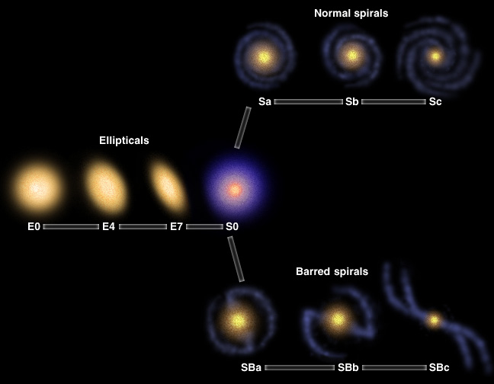

Now it’s time for the last subject, cosmos.

The study of cosmos structure is called “cosmology”.
And in my eyes cosmology is the only thing which is more interesting than black holes!
We know that all of the things I have written about exist in the cosmos.
But how is cosmos shaped? Does it have an end? Was it God or the “big bang” which started everything? Is there life on other planets?
If we ever will be able to find the answers on these questions we need to find a way of travelling very, very fast. Maybe through black holes?

Conclusion

This essay was rather easy to make. It was easy to find good facts on the internet and it was almost just a pleasure to work whit it!
I think that I have learned a lot of astronomy after this work. For example I know that we perhaps not are the only intelligent creatures out in the cosmos! There are billions of galaxies out there and some of them have probably life in them. I also know that a star can die in three different ways and that there probably are more then ten planets in our solar system.
I really can say that I have learned a lot from this work. And I really hope that you learned as much as I did!

Sources:

- http://www.windows.ucar.edu/
- http://www.dd.chalmers.se
- “Stonehenge” by Robin Heath
- “Illustrerad vetenskap” no.2 2006

