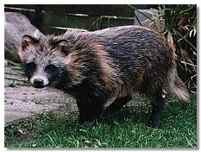
Racoon Dog (Nyctereutes procyonoides)
The Racoon Dog belongs to the marten family.

Appearance: It is a small animal, with stout legs and a thick body. The ears are round and the head looks like a racoon. The fur is has a brown-grey colour and it has black circles around its eyes, black ears and a bushy tail. They usually are 50-80 cm long and weigh between 5 to 10 kg.

Distribution: The racoon dog ranges in the wooded areas of Western Europe, Russia, China, and Japan. They were brought to Russia for hunting/breed purpose only. And has from the spread to other areas like, Scandinavia, Germany and France.

Food: They are effective in the night and hunts small rodents, insects and plants.
But their food habits change if they live, for example near the water, then they eats fish and frogs. The racoon dog goes into hibernation during the winter in the northern parts, but wake up now and then to find some food.

Reproduction: It gets sexually mature when they are 1 to two years. The mating season is in marsh and after three months 4 to 12 children are born. And the birth takes place in a old burrow or one they have built them self. And the racoon dog only lives for about 3 years, longer in captivity.

It can not bark like dogs, but it can make other noises.
The name is Greek and the it means; night-wanderer, Nyctereutes means night-wanderer, and procyoniodes means similar to a racoon.
And they have found fossils of relatives to the racoon dog and they are dated to 4 million years old.

