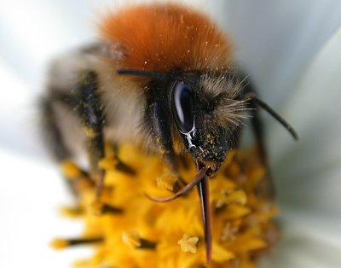
Bumblebee (Bombus Pennsylvanicus)

The Bumblebee belongs to the Bombus family. There are over 30 different species of Bumblebee.

It is a small insect that is black and white, with four wings and fuzzy bodies.

They live in communities with one queen, some males and a lot of workers.
The bumblebee queen wakes up from her winter sleep in mars-april.
She is very hungry and takes of to collect nectar and pollen. And the nectar and pollen becomes honey in her body. When she is content she starts looking for a place to build her new home, it probably is a deserted hole in the ground or in a tree.
She then starts to build a soft bed and the fry chamber.
And later she build the wax cells and there she store the honey for food.
In the fry chamber she put the eggs in the wax cells and after only a couple of days the maggots are born.
When the maggots have eaten up all their food in the wax cells the queen starts to feed them herself. Later the maggots pass into the chrysalis stage. And soon the first workers are born. And then she can concentrate to lay eggs.
In the late summer the real males and females are born and they copulate.
And when the autumn comes the queen and all the workers and males dies and the fecundated females survives to become the next queens and create new communities.

If a bumblebee sting you, it only does that in self defence. Their enemies is hedge hogs, moles and shrew mice, they eats the hole bumblebee home in their search for honey.
We are their enemies to because of our insect spraying.

