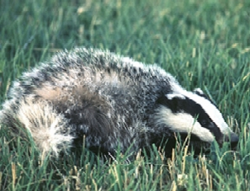
Badger (Meles meles)
Belongs to the marten family.

A grown up badger is around 90 cm long and weigh 15 kg. the fur is on the stomach black and on the back silver-grey.
The colour of the skin under the fur is pink.
The head is white with two big black stripes on each side of the head, and it goes from the nose to the ears.
They live up to 15 years.

The Badger lives almost all over Europe, but not north of the arctic circle. In northern Asia for example Russia, China and Japan. In the mountains it only lives up to 2000 meter. The Badger likes the forests, but it might live in parks in a town.
The Badger came to Sweden after the latest ice age, and lived all over Sweden, but when the climate became colder the Badger moved south.

The Badger is a omnivorous. It eats fruits, nuts, fungus and seeds. It also eats eggs, worms, birds and mice. Sometimes it might eat a young hare.

The mating season is in mars-april and the baby Badgers are born in mars-april the following year. And the female give birth to 2 to 5 children.

They build a lair, that has a diameter of 30 meter. And in the middle, where the Badger lives, are about 5 meters bellow the surface. One lair might be used through decades or even centuries. Every generation builds new rooms and new paths. There might be many Badger families that share one lair. In the lair there are always one couple there are dominant, and they live all their life together.

The Badger are almost only effective during the night. And in a colder climate they go into hibernation, that last through days or months.

