3 av 7
Compulsory facts

Iceland is a country that belongs to the Nordic countries.
Iceland is an island in the north Atlantic.
The island is the top of a volcano ridge in the ocean.
Iceland has developed by a volcano eruption.
The volcanoes are still active to day.
Iceland is a relative new country it has just existed in 70 million years.

By the word Climate we mean weather during a part of time.
The climate in a country depends on many things
for example the sun, how high the country is compared to the water and how close it is to the water.

Although Iceland is situated so far north is has a pretty mild climate.
It depends on the golf steam that passes on the both sides of Iceland.
Low pressures that is built up on the Atlantic Ocean takes the same way as the golf stream. That is why it rains often on Iceland, more in the south then north.
It is drier in the north parts.
In the south it rains more then 1000 mm/ year and in north it rains less
then 500 – 700 mm/ year.
The fjord gives a curtain protection against weather and wind.
It isn’t such a big different climate between summer and winter.

| Golfströmmen gör så att landets klimat är milt året om.
I den södra delen av landet är det lägst är den lägsta vintertemperaturen -10 C och i den norra delen är det -15 C. |

Under sommarhalvåret blir temperaturen som högst 23 C samt 24.5 C i norr.
Det är växlande väder.

The nature on Iceland is very special.
There is almost no forest, and big areas are lava.
In the middle of Iceland the landscape consists most of glaciers, stone and gravel.
It is a really barren landscape.

The people who lives in Iceland build there houses with concrete.
It is the material that is the best for the climate.

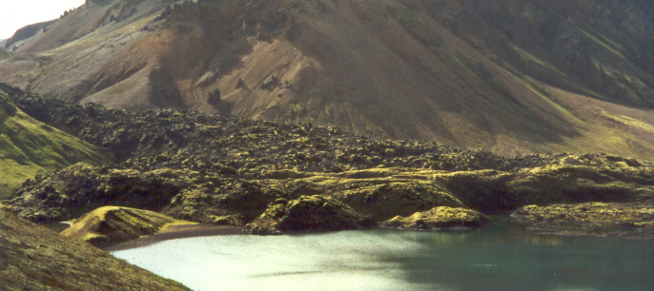

4 av 7

The volcanoes on the island are big natural recourses to the society.
People on Iceland use the hot springs to warm up houses and to
give them hot water.
The capital city Reykjavik is warmed up by water from the springs.
They also heat up greenhouses were they grow different plants like bananas, tomatoes and other fruits and vegetables.

What are the people living on when the climate is cold, windy, rainy
and there is only small parts of the country were you can cultivate?
1.5 % is cultivated land on Iceland.
In the agricultural districts they grow mostly food to the animals.
The farmers on Iceland have focus on the milk production and sheep tending.

Other big natural recourses are fishing.
North Atlantic Ocean belongs to the world’s best fishing water.
Thanks to the hot golf stream there is a lot of plankton, fishes like herring and thrush eats plankton.
It is not very deep around Iceland so the fishes like the area when they are ready to spawn.
Many people works as fishermen. If the father is a fisherman his son probably also become that.

Water and earth power are other resources.

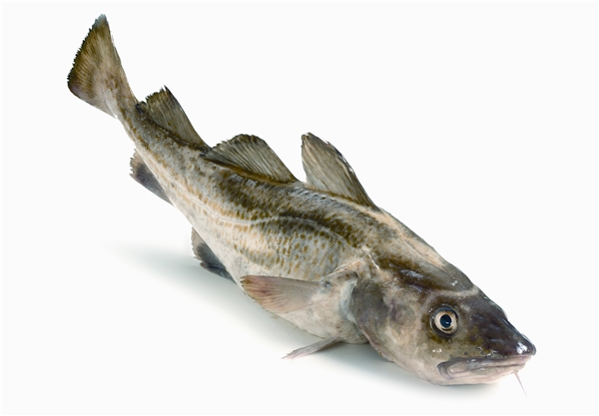

5 av 7

Reykjavik is the centre of Industry and commerce.
It is also the biggest city on Iceland and it has a lot of tourist so they need to have hotels, restaurants and stores.
The tourism is the second biggest income for the people.
The tourists like to buy the famous jumpers made by wool.

The most important industry is the fishing, the economy depends on how the fishing industry works.
70 % of the export from Iceland is fish.
There are lot of rules about fishing.
Iceland doesn’t want to be a member of EU, they are afraid that the politicians are going to restrict the fishing industry.
There are two places, Reykjavik and Vestmannaeyjar were the fishing
Industry is biggest. They export fish most to USA and Europe.

Other things to export are; aluminium, silicon iron and sheep products like meat, skin and wool.

It is very expensive in Iceland, so many people have two or three jobs.

| Island befolkning bor längst kusterna och dalgångarna.
Det bor inte så många människor på Island, det är väldigt glesbefolkat.
Framför allt bor det folk i den sydvästliga delen av Island där de lever av fiske och jordbruk.
I Reykjavik bor det ungefär hälften av befolkningen på Island.
Många människor lever av fisket som huvud inkomst, därför bor det många människor längs kusten. |

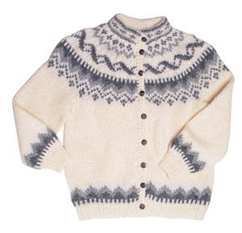

6 av 7

Discussion

Iceland

Iceland is a very special country. They don’t have many different industries.
For example the fish likes the water area around Iceland, so the biggest industries for the people to work in are fishing.
You need people out on the boats and you need people who work in the fishing industry. Some people works with the export of the fish.

Despite the climate witch is rainy and cold the sheep farmers get big incomes from the work with the sheep’s. They export meat and wool.
They also get incomes from the tourists who like to bye the special wools jumpers.

Iceland compared to Sweden

The biggest different between Iceland and Sweden are the forests.
Iceland hasn’t got any trees but Sweden has a lot of trees and that is a big export industry for Sweden. The trees can’t grow very well on Iceland because of the lava ground.

Iceland hasn’t got the problems with the electricity like Sweden has. In Sweden we have to import oil and we need to have nuclear power station.
In Iceland they have there own natural resources like earth and wind power, so the hot springs and the volcanoes gives them hot water and electricity.

Sweden has good conditions for agriculture.
Thing grow really good in Sweden thanks to the climate.
In the winter time when it is cold noxious animals can’t develop, so we don’t need to use means of control.
The crops don’t need so much water because it is not so very hot.
In Iceland they have built greenhouses so they don’t need to import vegetables.
They can’t grow crops because the earth isn’t so good for it.

In the winter time we have almost the some temperature as Iceland,
but in the summer it is much colder In Iceland.

| Island jämfört med Sverige
Sverige är ett långt land med stora temperatur skillnader mellan landsändarna.
I Sverige kan vi uppleva allt ifrån tropiska förhållanden till extremt kyligt väder.
Vi har haft temperaturer upp till 38 C i södra Sverige och -52.6 C i lappland.
Att det är kallare i norr än i söder beror på ekvatorn. Värmen från solen är som starkast mot ekvatorn. där för är det varmare i söder än i norr.

På Island bli lägsta temperaturen c:a -10 C - 15 C på vintern och på sommaren ungefär 23 – 25 C.
Det är ett jämnare klimatet beror på golfströmmen.

Nederbörden i Sverige är rikligast på sommaren och hösten.
Det mesta av nederbörden hamnar i västra Sverige.
När norges gräns i fjällen faller det c:a 1500- 2000 mm/ år.
I sveriges syvästra delar faller c:a 1000- 1200 mm/ år .
I övriga delarna ligger årsnederbörden runt 500- 800 mm/ år.
Detta kan jämföras med Islands genomsnittliga nederbörd på 1000 mm/ år i dom södra delarna och mindre regn 500- 700 mm/ år i dom norra. |

