Counter-Strike – The World’s #1 online action game

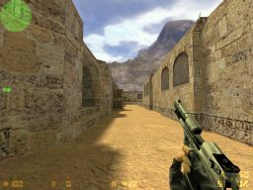
Counter-Strike is the world’s number 1 action game and is played in teams over the Internet. Today it’s the most popular online game in Sweden with around 200 000 Swedish players. In the whole world it’s around 20 million active players. Schroet Kommando (SK) is the world champions from Sweden.

Counter-Strike is about the terrorists and the counter-terrorists to kill each other on a map. The terrorists have got a bomb that they have to plant on one of the two bombsites, but the bombsites are hardly supervised by the counter-terrorists. The counter-terrorists task is to defuse the bomb. So either you kill the opponent or you plant/defuse the bomb to win the round.

Some players are in a team called a clan. In a clan you can be 2 people or more and play matches against other clans and a match against another clan is called ”pcw”. On a pcw you play 12 rounds as a terrorist and then you switch teams and play 12 rounds as a counter-terrorist.
When a clan plays a pcw they are sitting on different places and are communicating with headphones and microphones.
Before a big competition the members of the clan meet in an internet café and trains more than usually.

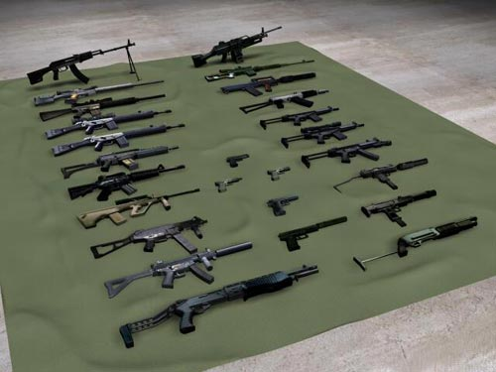
Under a LAN-party (Local Area Network) you meet Counter-strike players to play with each other. Here you meet players you only have met over the internet. But on the LAN you learn to know them better on the same time as you are playing.

SEL (Swedish Esport League) is the Counter-Strikes players own league. In this league there are the best clans in Sweden playing.

I play counter-strike myself and I think it is really fun to meet other people and to play the game of course. I think I’m good on it and I’m playing it quite often.
You play the game on servers and there are 10 000 servers or more all over the world. I got a server myself. I have played in 3 years soon!
This is a game you can play for years! You can’t stop playing it, it’s so fun.
So, if you like first person action game, then you should buy it! It is so fun when you have learned the controls and the tactics.
If you want to buy Counter-Strike then you have to go to a Computer store and buy
Half-Life: Counter-strike or Half-Life Generation Pack. But you can also buy it on the internet.
Counter-Strike cost around 12$, but it differ from different stores.

