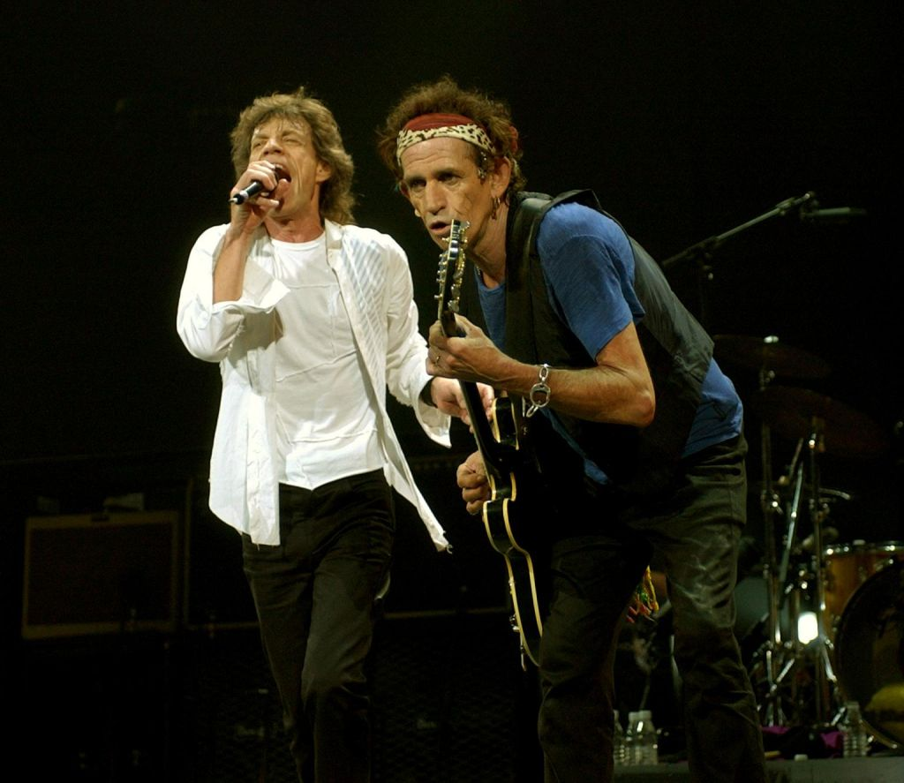

Hannes Berg 2005

Group members

The Rolling Stones is an English group build in 1962 in England, the original member are:
Mick Jagger: His real name is Michael Philip Jagger. He was born 26 July 1943 in Dartford. He is the lead singer.

Keith Richards: Born 18 December 1943 in Dartford. He is the lead guitar player and sings.

Brian Jones: His real name is Lewis Brian Hopkin-Jones. He was born in
28 February 1942 in Cheltenham. He died 3 July 1969 at Cotchford Farm Sussex, He played guitar, organ and he sang. After Brian’s dead took Mick Taylor over, he was born 17 January 1948 in London. He was a member from 8 June 1969 until December 1974 during 1975. Ronnie Wood replacement him.
Ronnie Wood was born 1 June 1947 in Hillingstone.

Billy Wyman: His given name was William George Perks. Born 24 October 1936 in Lewisham. He plays bas and sings.

Charlie Watts: Born 2 June 1941 in London. He plays drums.

Facts

In the beginning Rolling Stones have strong influence of American R&B and blues. At their three first records they have copies of Chuck Berry, Muddy Waters and Solomon Burke.
Rolling Stones (Jagger and Richards was writers) became very famous after
“I can’t get no Satisfaction” and “Paint It Black” from the album “Big Hits”.
“Big Hits” became a big hit in USA and Europe. The Rolling Stones was now a very big name in the whole world. The concerts were at the beginning forbidden, because the audience made chaos and Jagger, Richards and Jones lifestyle. The artist were known hard drug takers. In 1967 they stopped to play public. During 1969 they start to tour again. They had a free concert in Hyde Park in 1968 as a memory for Jones. He had leaved Stones in 8 June 1969 because musical disagreement. He was found drowned in his pool. Stephen Woodley’s film Stoned is about Brian Jones last three weeks in life and it have been approved by Rolling Stones

Rolling Stones image was from the beginning hard brutal and sex, drugs and Rock ´n´ Roll. They left the blues at the fourth album and especially at the psychedelic ninth album.
Richards guitar playing have influence of Chuck Berry’s guitar riffs. Jaggers’ voice is very strong and rasping. Jaggers’ scenery has been suggestive of sex.
Rolling Stones have very many supporters around the world. Not only old men, young kids like them to. They have reached a mythological status. At the end of 1986 there was a rumour of break up, without the group comments the thing.
Everybody in the group recorded albums on there own whit exception Watts.

Mick Jagger have recorded albums whit Peter Tosh and David Bowie. He had the principal part in films like Ned Kelly and Performance from 1970.

Richards, Jagger and Watts appeared in publican in July 1985 at Live Aid. They have played in Sweden many times. Last time was in 2002 at Ullevi in Gothenburg. They are going to play there in the summer of 2006.

Scandals

There have been many scandals around the group.
Keith Richards and Mick Jagger have been prosecuted for possession of narcotics and hash.
They have been called devil-worshippers because “Sympathy for the devil” and “Jumpi´n Jack Flash”.
The most of the scandals was about sex and drugs.

Albums

Vinyl
Release Date Title Highest Chart Position
Apr. 64.  Jan. 65.  Sep. 65.  Apr. 66.  Nov. 66.  Jan. 67.  Dec. 67.  Dec. 68.  Sep. 69.  Dec. 69.  Sep. 70.  Apr. 71.  Apr. 71.  May. 72.  Aug. 73.  Oct. 74.  Jun. 75.  Apr. 76.  Sep. 77.  Jun. 78.  jun. 80.  May. 81.  Sep. 81.  Jun. 82.  Apr. 86. | The Rolling Stones.  The Rolling Stones No.2.  Out Of Our Heads.  Aftermath.  Big Hits - High Tide And Green Grass.  Between The Buttons.  Their Satanic Majesties Request.  Beggars Banquet.  Through The Past Darkly (Big Hits Volume 2).  Let It Bleed.  Get Yer Ya Ya's Out.  Stone Age.  Sticky Fingers.  Exile On Main St.  Goats Head Soup.  It's Only Rock 'N' Roll.  Made In The Shade.  Black And Blue.  Love You Live.  Some Girls.  Emotional Resue.  Sucking In The Seventies.  Tattoo You.  Still Life (American Concert 1981).  Dirty Work. | U.S. 11  U.S. 5  U.S. 1  U.S. 1  U.S. 2  U.S. 2  U.S. 2  U.S. 2  U.S. 2  U.S. 2  U.S. 5  U.S. -  U.S. 1  U.S. 1  U.S. 1  U.S. 1  U.S. 6  U.S. 1  U.S. 5  U.S. 1  U.S. 1  U.S. 17  U.S. 1  U.S. 2  U.S. 4 | U.K. 1  U.K. 1  U.K. 2  U.K. 1  U.K. 4  U.K. 3  U.K. 3  U.K. 3  U.K. 1  U.K. 1  U.K. 1  U.K. 5  U.K. 1  U.K. 1  U.K. 1  U.K. 4  U.K. 10  U.K. 2  U.K. 3  U.K. 2  U.K. 1  U.K. -  U.K. 1  U.K. -  U.K. 3

CD

Release Date Title Highest Chart Position
Jan. 83.  Mar. 84.  Jul. 84.  Aug. 84.  Nov. 84.  May. 85.  Jul. 85.  Aug. 85.  Aug. 85.  Feb. 86.  Feb. 86.  May. 86.  Aug. 88.  Aug. 88.  Aug. 88.  Aug. 88.  Aug. 88.  Aug. 88.  Sep. 89.  Sep. 89.  Nov. 89.  Nov. 89.  Nov. 89.  Nov. 89.  Nov. 89.  Nov. 89.  Nov. 89.  Nov. 89  .  Nov. 89.  Nov. 89.  Nov. 89.  Nov. 89.  Nov. 89.  Jun. 90.  Oct. 90.  Apr. 91.  Jun. 91.  Jun. 91.  Nov. 93.  Aug. 94. | Beggars Banquet.  Undercover.  The Rolling Stones.  Out Of Our Heads.  12 * 5.  Aftermath.  Between The Buttons.  Hot Rocks 1.  Hot Rocks 2.  Their Satanic Majesties Request.  Let It Bleed.  Dirty Work.  December's Children (And Everybody's).  Flowers.  Get Yer Ya Ya's Out.  Got Live If You Want It.  More Hot Rocks Volume 1.  The Rolling Stones, Now.  Steel Wheels.  Singles Collection - The London Years.  Black And Blue.  Emotinal Rescue.  Exile On Main St.  Goats Head Soup.  It's Only Rock 'N' Roll.  Love You Live.  Made In The Shade.  Rewind.  Some Girls.  Sticky Fingers.  Still Life (American Concert 1981).  Sucking In The Seventies.  Tattoo You.  Hot Rocks 1964 - 1971.  More Hot Rocks.  Flashpoint.  Big Hits (High Tide And Green Grass).  Big Hits Volume 2.  Jump Back.  Voodoo Lounge. | U.S. -  U.S. 4  U.S. -  U.S. -  U.S. -  U.S. -  U.S. -  U.S. -  U.S. -  U.S. -  U.S. -  U.S. -  U.S. -  U.S. -  U.S. -  U.S. -  U.S. -  U.S. -  U.S. 3  U.S. 16  U.S. -  U.S. -  U.S. -  U.S. -  U.S. -  U.S. -  U.S. -  U.S. –  U.S. -  U.S. -  U.S. -  U.S. -  U.S. -  U.S. 174  U.S. -  U.S. -  U.S. -  U.S. -  U.S. -  U.S. 2 | U.K. -  U.K. 1  U.K. -  U.K. -  U.K. -  U.K. -  U.K. -  U.K. -  U.K. -  U.K. -  U.K. -  U.K. -  U.K. -  U.K. -  U.K. -  U.K. -  U.K. -  U.K. -  U.K. 2  U.K. -  U.K. -  U.K. -  U.K. -  U.K. -  U.K. -  U.K. -  U.K. -  U.K. –  U.K. -  U.K. -  U.K. -  U.K. -  U.K. -  U.K. -  U.K. -  U.K. 6  U.K. -  U.K. -  U.K. -  U.K. 2

