Research Project


By: Philip.S
8:D

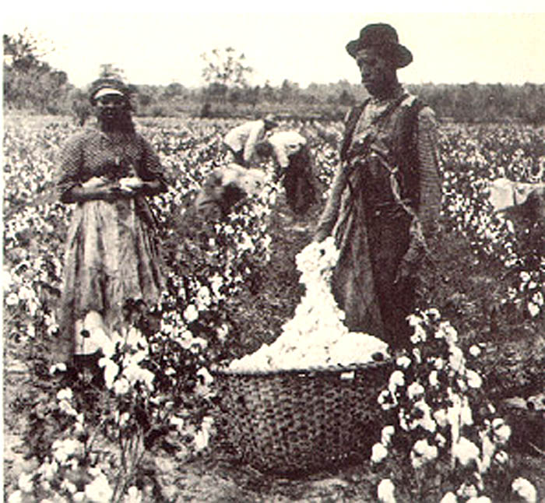
Cotton:
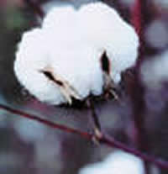
For thousands of years, cotton has been used to make lightweight cloth in tropical areas. Some people claim that the ancient Egyptians used cotton for 14,000 years ago. Proof was found that Mexican people used cotton for 7,000 years ago (cotton cloth and fragments were found in caves). Around 300 BC Alexander the great brought cotton into Europe. When it first came there it was so expensive that only rich people could afford buying it. In the 17th century American colonies began growing cotton. Slaves were used up until the abolition of slavery. The main use of the cotton in that time was for clothing.

In 2002, cotton growing took up 330,000 Km² of farmland. This made 21 million tons of raw cotton. The whole amount added up to a worth of 20 billion US dollars. The industry of cotton relies heavily on chemicals such as fertilisers and insecticides. As the new time has grown farmers have found ways to grow cotton non-chemically and that is a very good thing. Most cotton is harvested mechanically, either by a cotton picker, a machine that removes the cotton from the boll without damaging the cotton plant, or by a cotton stripper which strips the entire boll off the plant. The case of cotton harvesting and processing has been improved by the development of the cotton module builder, a machine that compresses harvested cotton into a large block, which is then covered with a tarp and temporarily stored at the edge of the field.

Before processing cotton, there are three steps to go through:
- Ginning - separates the cotton fibers from the seedpods.
- Spinning - Several fibers are twisted together to bind them into a strong, long yarn.
- Weaving – To turn the fibres into cloth by interlacing them.
After weaving, cotton passes through many processing stages. Many factories use these stages:
- Singeing – Burning the loose fibres sticking out of the cloth
- Desizing - Desizing is the process of removing the size material from the yarns in woven fabrics.
- Scouring – cleaning the yarn off.
- Bleaching – Apply chemicals to the yarn in order to make it look white.
- Mercerizing – making the cotton stronger.
- Dyeing – Changing the color.
- Finishing – making the last small details.
Cotton is used for many more things than clothes, for example many countries use cotton for their money because it does not get damaged in water. Cotton is also used in fishnets, coffee filters, tents and bookbinding.
You can machine wash cotton on a quite high temperature, from 40-90 degrees. 90 C º for bed linen. Tumble dry it or you can just hang it up on a hanger to dry. When ironing, iron it on a high temperature, if the care label doesn’t suggests anything else. Also iron it when the piece of fabric is damp.
The advantages of cotton are: cool, strong and long lasting. The disadvantages are: Burns very easily, gets wrinkled and shrinks.

Silk:
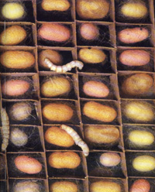
Silk is, has been and will always be a luxury product. It is very soft and very comfortable to wear. Silk was originated in china where there where bugs that actually created it. To be more accurate, the bugs are moths that spin themselves into a cocoon made up of silk to protect them. When the cocoon was finished the Chinese women collected all the cocoons and boiled them in water so the moths died. When all the moths were dead they separated the silk from the moths and made it into strings.
Silk is white with a touch of grey that you never see because it has already been dyed into another colour.
There are two types of silk, natural and synthetic. Synthetic silk is made from lyocell which is a cellulose fibre. The difference between the both is hard to see and feel.

If you want to wash silk it is very important that you use non-alkaline soap and water. To dry the silk take a towel and roll it in, then take it out and let it lay on a flat surface.
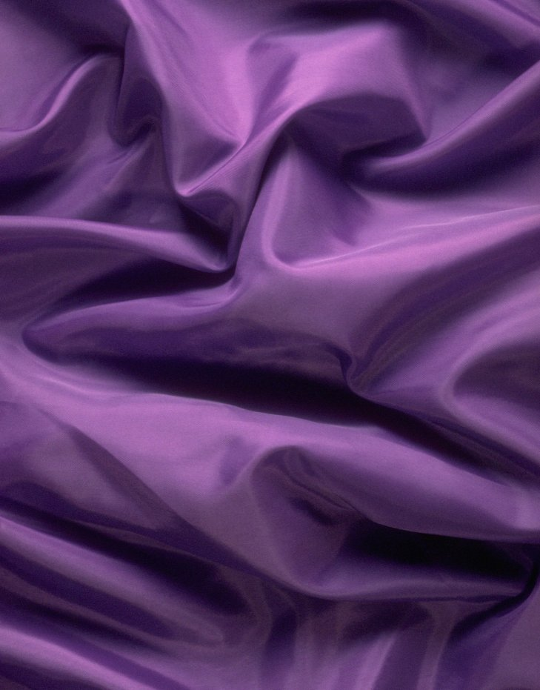
One big disadvantage with silk is that it gets destroyed in high temperatures, so you can’t
Iron it in high temperatures.

Silk is used for many things like clothing, mats, and towels and so on.

Wool:

Wool has been available since the day sheep set their feet on earth, but it has been used since the shear was invented

The properties of the different types of wools aren’t so different. They are only different because the different wools come from different animals. Then the shape of the wool is depending on the race of the animal, the climate in its habitat and what it eats. All these things decide how the different kinds of wool are like.

The 4 biggest producers of wool are:
- Australia, with 29, 1% of the market with unwashed wool and 31, 6% of the degreased wool market.
- New Zealand, with 10, 4% of the market with unwashed wool and 13, 1% of the degreased wool market.
- China with 10, 3% of the unwashed wool market and 9, 0% of the degreased wool market.
- Russia, with 3, 9% of the market with unwashed wool and 4, 0% of the degreased wool market.
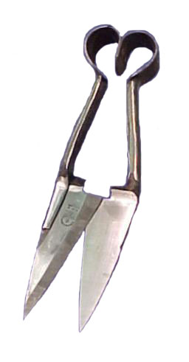
The process of wool starts when the sheep gets cut. This is mostly done with a machine nowadays. Before there were machines the sheep were cut with a shear like on the picture →
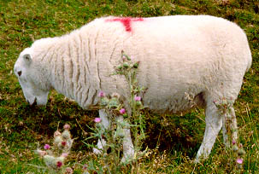
When all the wool is collected you have to wash it for 2-3 days. While you are washing it you have to dry it on a flat surface and NOT hang it up, that will make it stretch.
When you wash wool you have to activate a special “wool function” that most modern washing machines have. When ironing wool the iron must not touch the surface of the wool because it will ruin the fabric. To not ruin it you have to hold the iron around 2 cm above the surface.

Some uses of wool are sweaters, blankets, coats, suits, shirts, pillows and hats.
The most common one of these is the sweater, which is very popular here in Sweden.

Advantages of wool are: Absorbent, elastic, comfortable, easy to get, washable and it is a good insulator. Disadvantages are: it is expensive, it can be itchy, and it is the weakest of these ten fabrics and is sensitive to alkaline.

Linen:
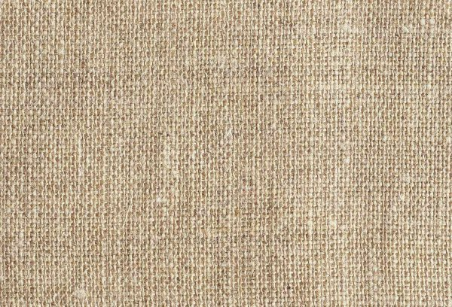
Linen is made from a plant in the lineum family called flax. You take the stalks that hold the fibre and work so it becomes linen with help from many different chemicals. The last part is when you pack the linen up. The best way is to pack it with water which gives you the best yarn.
Linen has been used since 7,000 years ago. It was in the Ancient Egypt that this was used. The flax plant was one of the major plants that they planted. While today, China is the biggest producer of linen.
Linen is commonly used in kitchens and bedrooms, in for example cloth, canvases, sails, tents, and paper. Linen is also used for decorations. Linen is also a very strong fabric; it was used for shields and gambesons during the medieval time.
Have a degree of about 50 degrees when you machine wash linen, you should also be aware of that if you have washing powder, this will bleach the linen. Be sure not to have other clothes in the washing machine at the same time as you wash the linen, this will make the linen look ugly. When you iron it the linen must still be damp and the iron on a high temperature.
The advantages with linen are: It is very strong, it is nice to touch and it is beautiful. The disadvantages are: It is easily creased and hard to iron.

Denim:

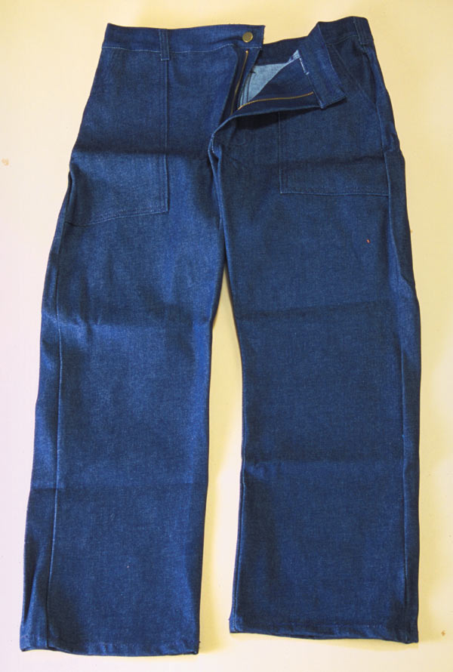
If you take cotton and weave it up really tight you get denim. It’s a really strong material which was first used in a French City called Nîmes. It’s originally white but is coloured into blue normally.
Denim is used mostly for jeans, in 1873; Levi Strauss started a factory in California which produced denim jeans. This was good for cowboys and workers since they needed strong clothes that did not break in the first place. In the 1930’s it became normal to have denim jeans in the states. By WW2 denim was spread all over the world. The real denim fashion started in the 60’s when not only jeans were produced, but also hats, shirts, jackets and much more.

When you wash denim you should wash in no more than 45 Cº, if you have higher temperatures the clothing will get damaged. You can iron denim, but you really shouldn’t because it causes the denim to get stiff.
The big advantage of denim is that it is really strong and hard to break. A disadvantage is that it is hard to strech.

Nylon:

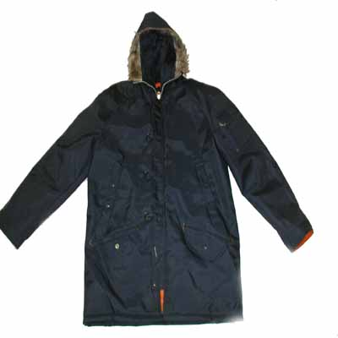
Nylon is a synthetic polymer, a plastic, invented on February 28, 1935 by Wallace Carothers at DuPont of Wilmington, Delaware, USA. On the 28th of February 1938 the first nylon product was announced, a nylon bristle toothbrush made up of nylon yarn. In 1940, women’s’ stockings were announced. Nylon fibres are now used to make many synthetic fabrics, and solid nylon is used as an engineering material.

Nylon is made through this process: Polymer molecules are pumped into an airshaft where they are stretched and solidified. After that the fibres are put into piles and then you melt them again and take them to the airshaft where they are solidified and stretched again. This process is repeated several times to make the nylon get stronger.
A nylon military jacket.
Some of the uses for nylon are: Clothes, car accessories, nets, threads etc. These things need to be like nylon is, elastic and quite strong.
To iron nylon, you need a really hot iron if the clothing doesn’t say anything else. When you wash it you have to have a fairly low temperature.
The advantages are: Strong fabric, elastic and long lasting. The disadvantages are: very good conductor of electricity, doesn’t absorb water well and is sensitive against chemicals.

Acrylic:

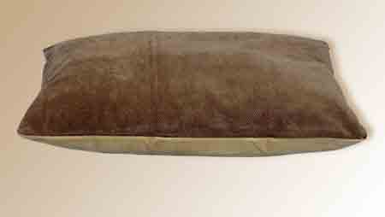
During the 1950’s, a fabric called acrylic was created by a company called DuPont in America. It was made of 85% of a synthetic fibre called acrylonitrile which was made up of small other chemicals. When it was exposed to light the acrylic turned yellow or brown. They had to make some small changes before they could manufacture it around America.
Today Acrylic is used a lot in the textile industry and is created in very big volumes; you can find it in many different variations like apparel including sweaters, fleece fabrics, and socks and in home furnishings such as furniture, carpet, blankets, and upholstery fabrics.
The acrylic fibres are very light and have a low absorbance of moisture. They keep the shape, they don’t get wrinkled so much and they don’t shrink.
When washing acrylic you should have around 40 Cº otherwise you can damage the fabric. But it handles acids, weak alkalis and organic materials. When you iron it you have to have a medium temperature.

Advantages are: handles many things, dries quickly, light, and handles chemicals well. Disadvantages are: burns easily, hard to pack it, bad heat resistance.

Viscose:

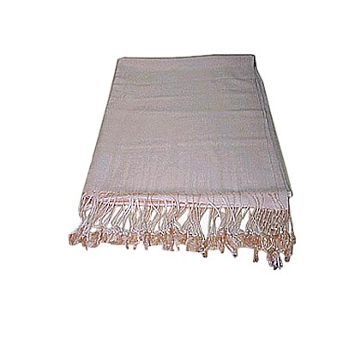
Charles F. Cross, Edward T. Bevan and Clayton Beadle made, in 1891 a fabric that they named Viscose (they actually called it rayon, but Viscose is the international and modern name for rayon). It was patented in 1892 and started to get produced the same year. It went well up until the 60’s when other fabrics took over the market. This happened because it had a very polluting process of making it.
To make Viscose you first take some cellulose from cotton (they are similar to each other) or wood. ”Sodium hydroxide” is then needed to be mixed with the cellulose which is then mixed with” carbon disulphide”. This gives you” cellulose xanthate”. The next step is to dip it in some more Sodium hydroxide (NaOH) and then you’ve got viscose!
Some uses of viscose are, tight pants, sheets, shirts, sportswear and hygiene products etc. Basically it’s used where people need comfort.
The advantages of viscose are: elastic, absorbs well, easy to dye, comfortable and soft. The disadvantages are: extremely sensitive against acids and alkalies, creased easily, polluting production process.

When you wash it you should have a medium temperature in the machine and ironing needs a very cool temperature.
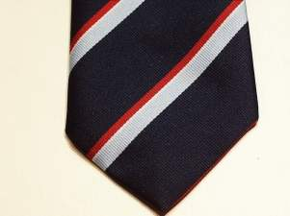
Polyester:

The synthetic fabric polyester was created during the 50’s. It was invented in 1941 by John Rex Whinfield and James Tennant Dickson and was patented as polyethylene terephthalate. It was manufactured by the Du Pont de Nemours & Co.
There are two ways of making polyester, one way is: You react dimethyl terephthalate with ethylene glycol so you get bis-(2-hydroxyethyl) terephthalate and methanol. You have to turn the heat up to get rid of the methanol which will disappear at around 210 Cº.
Some uses of polyester are: Carpets, curtains, draperies, sheets and pillow cases.
Almost all polyester can be machine washed and machine dried. A fabric softener is needed for the rinsing part. To iron it, have medium iron warmth.
The advantages of Polyester are: strong, resistant to stretching and shrinking, resistant to most chemicals, quick drying, wrinkle resistant and easily washed fabric. Disadvantages are: burns easily, stains aren’t easy to take away if you machine dry it on a low temperature, can be sticky.

Rayon:

Rayon is actually viscose, viscose is just the new name for rayon. There are three different modifications of rayon:
- ”High Wet Modulus”.
- ”High Tenacity Rayon”
- ”Cupramonium rayon”

Most rayon products should be dry cleaned but some can be machine washed and dried. . Many can be bleached but some are especially sensitive against chlorine bleach. Iron it on a cool temperature and when it is damp with a medium temperature.
Some uses for rayon are, industrial products, hygiene products, blouses, dresses, blankets, bedspreads, curtains, jackets, sportswear, ties and suits. Rayon is used when you need comfort and flexibility, like in sport activities.
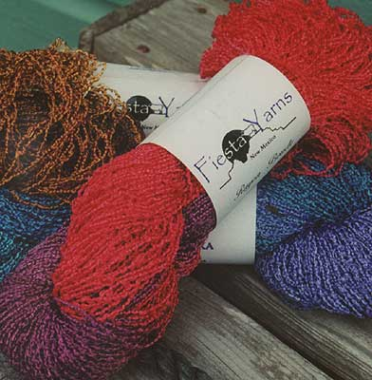
The advantages of rayon are: Good at absorbing, soft, easy to dye and really comfortable. The disadvantages are: sensitive against chemicals and shrinks easily when washed in the wrong way.

Sources:
www.wikipedia.com
http://www.levistrauss.com/about/history/denim.htm
http://www.fibersource.com
http://ohioline.osu.edu/hyg-fact/5000/pdf/5538.pdf
Various picture searches on Google ☺

