Street Race Syndicate

Street Race Syndicate is a new game that has been released to PC for about a month. When you are in the game at the beginning you start with racing a really good car. It’s one of the best cars in the whole game. Then after you has completed the race you get to choose your own car that you will customize with performance and visual settings in many different ways. The game is much like Underground 2 which is a street racing game that you compete with other players in the game. Everyone knows what a street race is. The only difference with these games and reality is that you don’t go to jail if you get caught and you have very much money. If you like good looking cars that move really fast, then these games are something for you. When you have played for a while it’s all about “Respect”. if you play better in races you get more respect and more money and you can race against more sophisticated cars and bigger races with a bigger pot. If you win these races you get performance upgrades or visual upgrades to your car or if you are lucky, maybe a new car. You can store up to 50 cars in your garage. You drive with cars that you have heard of but when you are done with it you’ll never recognise it, because you have so much styling on it that it’s unbelievable that you can do that to a car. Some of the cars that you can drive are Volkswagen Polo, Mitsubishi Lancer, Subaru Impreza and many more. You also have luxury models, like Lexus, Porsche and a few others. You can drive on really big skid, when doing that you will get performance points that show how good you really are at driving your car. While in the game you can also just drive around on the street and look after other performance cars like your own and race against them but while looking after them. (Don’t drive too fast) cops are included in the game and if you want outrun them you have to get to a freeway and drive 160 mph to have a chance! That’s no pussy speed in the game. You can lose control over the car in just 90mph and when there are other cars on the road, civilian it’s not easy to avoid them. Sooner or later you will crash into them! The graphic in the game is incredibly good. It almost looks real. You can choose if you want to see the whole car or just the interior inside it. Inside it’s really nice if you have styled it good. As in all games, there’s also many good looking girl that you as the player of the game call your girlfriend/girlfriend’s. You can have a whole lot of girlfriend’s with videos of them dancing really sexy… 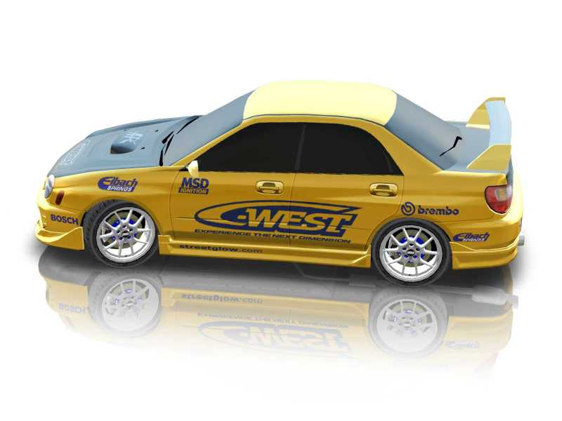
Emil Hansson is the Writer of this paper. Try the GAME!!

