ABRAHAM LINCOLN
By Malin Westman ES1DNa

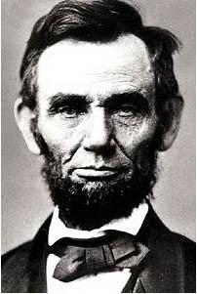

Early life

Lincoln was born on February 12, 1809, in Hardin County, Kentucky. His parents ( Thomas and Nancy Hanks Lincoln) were both born in Virginia. When Abraham was seven years old, the family moved to Indiana. He attended school with his older sister. Lincoln’s mother died in 1818 from milk sickness, a disease obtained from drinking poisoned milk. The following year his father married a Kentucky woman, Sarah Bush Johnston. Abraham loved his stepmother. She brought three children of her own into the household. As Abraham grew up, he just loved to read and to work in the fields. He constantly borrowed books from the neighbours. Abraham’s sister died during childbirth the same year.

Stories that Lincoln had a romance with a pretty girl named Ann Rutledge may well be true. Sadly, Ann died in 1835.

In Springfield in 1839 Lincoln met Mary Todd. Three years later they were married and over eleven years had four children: Robert (1843-1926), Edward (1846-1850), William (1850-1862) and Thomas (1853-1871).
Lincoln became a successful attorney, and the family bought a home at the corner of Eighth and Jackson in 1844.

Early in 1851 Lincoln’s father died.

Abraham Lincoln was an extremely versatile lawyer.

Election to the Presidency

In February 1860, Lincoln made his first major political appearance. He was now well known to be a presidential candidate. Although William Seward was the favourite for the Republican Presidential nomination, Lincoln won on the 3rd ballot. With Hannibal Hamlin as his running mate, Lincoln was elected the 16th President on November 6, 1860, defeating Douglas, John Bell, and John C. Breckinridge.
In February 1861 the Lincolns left by train for Washington, D.C. Lincoln was sworn in on March 4.

His presidency

Lincoln began his public career by claiming he was “antislavery” against slavery’s expansion but not calling for immediate emancipation. Lincoln had two main goals: he wanted to free the slaves and he wanted the United States to remain one nation. He knewed that the total and permanent end of slavery must be achieved. He served as counsel in two slavery cases: Bailey v. Cromwell (1841) and Matson v. Rutherford (1847). In the 1841 case, Lincoln victoriously argued for the freedom regarding an attempt to sell a black woman. (The converse presumption would have considered her a slave until she proved her freedom.)
President Abraham Lincoln was always against slavery on moral grounds. However, he was not an admirer of the black man, did not believe blacks should be granted the rights of American citizens, and did not wish that they be a part of American society. He believed that all blacks should be removed from the United States and resettled in some other country.

After the Election

After Lincoln’s election, many Southern states, fearing Republican control in the government, seceded from the union. After the fall of Fort Sumter, Lincoln raised an army and decided to fight to save the Union from falling apart. Lincoln stuck with this pro-Union policy for four long years of Civil War.
In 1864 the South was slowly being worn down. Lincoln was re-elected as President with Andrew Johnson as his running mate.
On Friday, April 14, 1865, the Lincolns attended a play entitled Our American Cousin at Ford’s Theatre.
During the performance Booth arrived at the theatre, entered the State Box from the rear, and shot the President at the back of his head about 10:15 p m. Lincoln was carried across the streets to the Peterson house where he passed away the next day at 7:22 a m. This was the first presidential assassination in American history, and the nation mourned its leader. Lincoln´s body was taken to Springfield by train, and he was buried on May 4, 1865.

Afterwords

Abraham Lincoln is remembered for his vital role as the leader in preserving the Union during the Civil War and beginning the process that led to the end of slavery in the United States. He is also remembered for his character, his speeches and letters, and as a man of humble origins whose determination and perseverance led him to the nation’s highest office.

Bibliography:

http://sc94ameslab.gov/TOUR/alincoln.html
14/4

http://www.whitehouse.gov./history/presidents/al16.html
14/4

http://home.att.net/~rjnorton/Lincoln77.html
14/4

http://civilwar.bluegrass.net/slavery
20/4

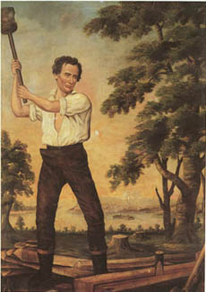

” I leave you, hoping that the lamp of liberty
will burn in your bosoms until there shall no longer
be a doubt that all men are created free and equal. “
-Abraham Lincoln

Abraham Lincoln

1809 - 1865

16th President
of the
United States

