Australien

Australia is in the Ocean. Australia is a very big island. The closest island is 310 miles from Australia. Australia is 300 meter over the sea. The highest mounting is Mount Kosciusko and is 2228 meter over sea. Australians lakes are 12 meter under sea. Australians biggest lake is Lake Eyre.
The longest river is Murray River and is 2560 meter long.

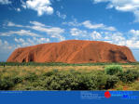

Australia has winter when we have summer and when we have winter they have summer. They have Christmas middle in the summer. In the inland they can not rain in many years.

Australians President is John Howard. It lives 19,2 millions people in Australia. 94 per cent are from Europe and 4 per cent are from Asian an 1,5 are Aborigines. Australians capital I Canberra and the biggest city is Sydney. They speak English, Italy, Aborigine and many other languages. Australians capital is Canberra and it lives 300 000 people there. But the biggest city I Sydney and it lives a little more than 3 and a half million people.

.

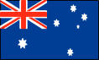

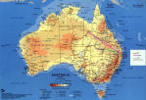

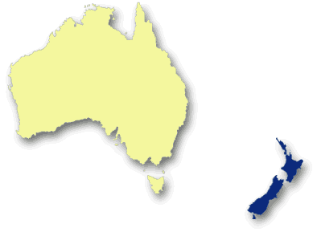
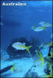

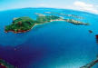

Animals

The pouch animals are the most popular animal in Australian.
it 230 different pouch animal in Australian. The kangaroo are the most popular pouch animal in Australian. Its 50 different kangaroos in Australian.

Kangaroo

The name kangaroo came not from the aborigines it came from the immigrant. The kangaroo can jump 8 meter. They can jump in 70 km/h.
They it many plants and flowers. When they goanna copulate so they stand up and have the balance on the tail and fight. Even to day kill 2 millions kangaroos every year

Koala bear

The koala bear can be 60 to 85 cm long. It has a short tail and has curly fur. Koala is grey on there’s back and white on the stomach. The koala bear are a night animal that means at the koala bear eat on the night and sleeping in a tree on the day.

The Great Barrier Reef

The Great Barrier Reef be at it Cairns.
The Great Barrier Reef is 2000 kilometers long. From Cairns are it 300 kilometres to reef. Corals have many colures the corals some living have colure them some are dead are white or grey.
If you do a trip to The Great Barrier Reef so remember don’t touch the corals. It lives 400 types of corals on the barrier and 1500 of fishes.
It 900 islands on The Great Barrier Reef. You can bath, sunbath and diving on the islands. One sea star eats corals that are a problem on these islands.

Aborigines

The Indigenous people of Australia are the Aborigines. The Aborigines have the longest, living, and cultural in the world with proof dating back to the last ice age. It is believed that when Asia and Australia were connected the Aborigines travelled across a land bridge to Australia and Tasmania which was approximately 70,000 years ago. The Aborigines didn't have agriculture so they lived off the land. Their only option for food was hunting. The Aborigines moved around constantly so they only took with them what was essential. There were approximately 500 different tribes of Aborigines in Australia. Each tribe had their own territory and dialects or language. Aborigines spent most of the day collecting and hunting food. In their spare time they had many dances, festivals; they made sculptures and made paintings. These paintings were made using natures surroundings. The paintings were often of animals, nature and people.

