Childhood

Martin Luther King Jr. was born on the 15th of January 1929. His father, who was a Baptist, was named Martin Luther King, and his mothers name was Alberta Williams King. Martin Luther King Sr. was a Baptist in”Ebenezer Baptist Church” , which was one of Atlanta’s biggest church.
Martin Luther King Jr. grew up with a segregated society where the black people didn’t have the same rights as the white. The black people had for example their own waiting room at train stations, and there was special “Black Restaurants” and “White Restaurants”.
Martin Luther King Jr. decided early that he would do something about the segregation and the unfair society.
Martin grew up in a good family, and they weren’t rich but not poor either.
Martin was very smart, and he skipped many grades. When he was 15 he started to study psychology at “the Morehouse College”, and his classmates were three years older than him. “The Morehouse College” was one of the finest schools for black people in all America.
At this time Martin decided that he would follow his father and also become a Baptist. His father, King Sr., told Martin Jr. that if he wanted, he could hold an own preach in his fathers church.
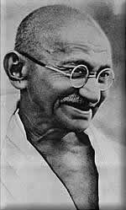
Martin Luther King Jr. showed that he was very good at holding speeches, and even if he only was 17, many people from all over Atlanta came to ”Ebenezer Baptist Church” to hear Martin Jr. talk.
In 1947, when Martin was 18 year, he moved to Pennsylvania and began to study at the “Crozer Theology Seminary”. It was here that Martin first came in touch with Mahatma Gandhi, and his non-violence methods. Ghandi became almost as an idol for Martin.
A few years later Martin started at a new school, and this time he went to Boston, to study at “the Boston University”. He was very serious and ambitious in school, and he was also popular around the girls. It was at “Boston University” he met Coretta Scott, which he married in 1953. The year after, Martin gets a job application as a Baptist in the southern town Montgomery. The southern states in America were much more segregated than the rest of the country, and racial associations like KKK had their strongest support there. But Martin wasn’t afraid, so he and his wife moved to Montgomery. One year later, in 1955, Martin took his doctors exam in theology, and now he was known as Dr. Martin Luther King Jr.
Mahatma Ghandi

The bus boycott

When Martin came back to the south of America, he noticed that almost nothing had changed. The segregation and the oppression against the black people were still there.
One day the black woman Rosa Park stepped on a crowed bus. She had been working all day and she was very tired so she took the only seat that was free. At the next bus stop two white men walked into the bus, and they said that Rosa Park should stand up and let them get her seat, because that was the law. When Rosa Park refused to leave her seat to them, they called the police and she got arrested.
Martin did get involved in the incident, and he realized that something had to be done. He started “the Montgomery Improvement Association”, which organized a major boycott against Montgomery’s bus company. No black people would go by bus until the bus segregation laws had been removed. Over 50 000 black people in Montgomery started to walk to their jobs, and it became very expensive for the city.
The 21 on February 1956 Martin and some associates in their organization were arrested for breaking the law, and a big trial was held. The court found Martin and his associates not guilty, because that it was the segregation laws that were illegal, because it fights against the constitution laws.
The government taught that the bus boycott wouldn’t be very long, but after 382 days the US government forced Montgomery’s bus company to change their laws.
The same boycott happened in Tallahassee, Florida, and after a six month long strike, Tallahassee’s public busses were also desegregated. Now could black people take any seat they wanted, and not be forced to move if a white person wanted the seat.
During the boycott, Martin received many threats, and even assassination attempts. Martin’s house was bombed in a murder attempt, but no-one was hurt.
The year after the boycott Martin, along with labor leaders, concerned ministers and activists started an association called “Southern Christian Leadership Conference” (SCLC). Martin Luther King was elected as the president of the association, and the association should approve the situation for the black people in the southern America. The same year Martin moved back to his home town Atlanta and started as a priest in his father’s old church.

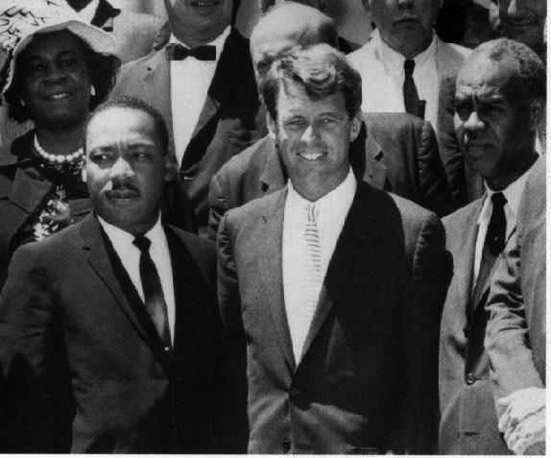
The sit-ins

In 1960 another big strike took place. Four black students walked into and sat down at a table reserved for white people only. They were thrown out, but the next day they did the same procedure. Those actions made many of the white people frustrated, but some of them realized that the segregation was wrong. The “sit-ins” spread across the America, and many black people followed their strike and walked into white restaurants and toilets. Marin, who participated in the sit-ins got arrested and sent to four months of hard labor.
Martin Luther King and John F. Kennedy
This year it was an election year, and the candidate John F. Kennedy saw his chance to gain votes. He commanded to release Martin, and acquit him all charges. This event made that many black people voted for Kennedy, and he won the election.

I have a Dream

In 1963 Martin organized a peaceful protest march in Birmingham, but the march was stopped by white polices armed with dogs and water canons. The police took their water canons and fired at the peaceful demonstrators. TV-channels from all over America was sending live pictures when innocent demonstrators were flushed away. Many people became angry on what they saw on TV, and joined SCLC and other human right organizations. The US court founded the Birmingham police acting’s illegal.
Three months later Martin Luther King and his association organized a huge and very famous protest march in Washington DC, where over 250 000 people was marching for human rights and equal treatment. After meeting President John F. Kennedy, Martin Luther King was delivering his most famous speech “I Have a Dream”, at the Lincoln Memorial.
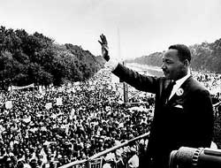
Here are some famous parts of the speech.

“I have a dream that one day on the red hills of Georgia the sons of former slaves and the sons of former slave owners will be able to sit down together at the table of brotherhood.
I have a dream that one day even the state of Mississippi, a state sweltering with the heat of injustice, sweltering with the heat of oppression, will be transformed into an oasis of freedom and justice.
I have a dream that my four little children will one day live in a nation where they will not be judged by the color of their skin but by the content of their character.”
Martin Luther King at the Lincoln Memorial

The listener was cheering, and the speech affected the whole country. Many TV-channels in the US was sending the speech live, and it was also broadcasted widely over the earth.
The next year Martin Luther King received the Nobel Peace Prize for his non-violent acting and his humanitary achievement. With the age 35, it made him the youngest person ever who had received that price.
In the 2nd of July 1964, the US President Lyndon Johnson signed the Public Accommodation and Fair Employment sections to the Civil Rights Act. It mean that after signing that law, black and white persons had the same rights, and it did also made I illegal to discriminate someone just because he or she is black.

The Assassination

On the 3rd of August 1968 did Dr. Martin Luther King hold his last speech in Memphis, Tennessee. He said at the end of his speech “I’m not fearing any man. Mine eyes have seen the glory of the coming of the lord”. He also said “Like anybody, I would like to live a long life. But I’m not concerned about that now. I just want to do God’s will”.
The next day he got assassinated when he walked out on his balcony at his hotel. A sniper was hidden in another building and shot him in the head. James Earl Ray was later arrested for the murder, and the court found him guilty. There are many speculations that FBI or CIA had planned the murder.
Five days later did a huge ceremony take place in his father’s old church. The ceremony was live on several TV stations, and over 100 000 people had come to stand outside of the church and hear at the ceremony through speakers. He is resting at the South View Cemetery in Atlanta, and over 300 000 people were marching with his coffin.
On Dr. Martin Luther King’s grave it says “Free at last, free at last. Thank God Almighty, I’m free at last”.

.
Conclusion

Martin Luther King is one of the most fascinating people I have read about. He is also one of the strongest, and even if he had been threatening many times, and several times he had been very close to gets killed, he still believes in his non-violence theories. In the US, the third weekend in February is called the Martin Luther King-day. On that day the whole America is honoring Martin Luther King, and what he did for the humanity.
If Martin Luther King didn’t have lived, I think that there would be a lot more racism today. Martin Luther King have been a symbol, and a prototype for many young people today.

“Darkness cannot drive out darkness; only light can do that. Hate cannot drive out hate; only love can do that” - Martin Luther King Jr.

Sources

www.retorik.com/tal/king.html

www.thekingcenter.com

www.martinlutherking.org

www.missionskyrkan.nu/html.php?html_id=13

www.baptist.se/mlk

Martin Luther King

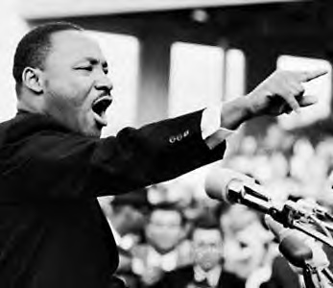
The Hero of Our Time

