TABLE OF CONTENTS

Father Christmas or Santa Clause 2

Christmas Tree 2

Preparations 3

Christmas cards 3

Christmas Day 3

Christmas dinner 4

Boxing Day 4

Christmas Crackers 4

Christmas Carols 5

The differences and similarities 5

My own thoughts about Christmas 5

List of references 6

Christmas in England

Christmas is England’s most popular holiday. This holiday has been a part of England traditions for many hundreds years back in time.

Father Christmas or Santa Clause 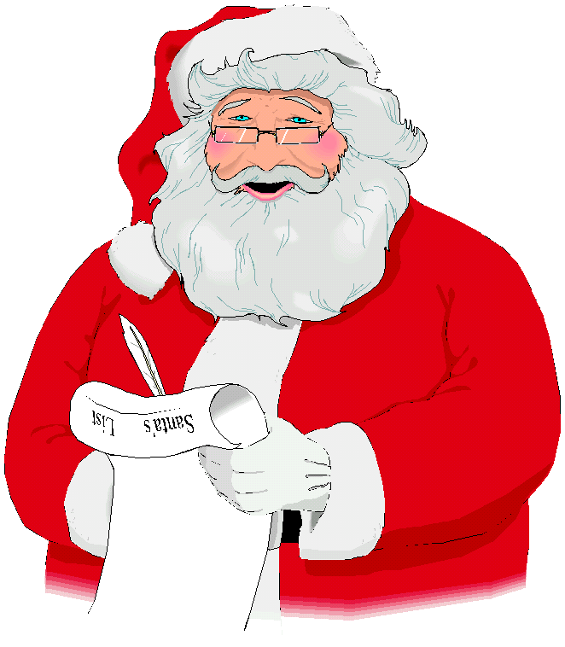
Children write letters to Father Christmas to tell him what they wish for Christmas. Some children send their letters by post or e-mail. The most traditional way to send your list is to throw the letter into the fireplace. Then, when the wind comes it takes up the letter through the chimney to Father Christmas.
Father Christmas is our version of Santa Clause. He is an old cheerful man, with white hair, a beard and a moustache. He is dressed in a red suit outlined in white.
Every year Father Christmas and his little workers make all the toys for Christmas at his home in Greenland.

Christmas Tree 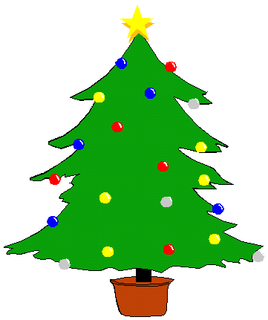

The Christmas tree is a very important symbol both in England an in Sweden.
The first Christmas tree came to England in 1841. Queen Victoria's husband Prince Albert brought it over from Germany to put it in Windsor Castle. Each year between 34-36 million Christmas trees are sold to the English families.

In both countries the day before Christmas, you gather the family to decorate the tree. You decorate it with tinsel, lights and small decorations, which hang from the branches. Chocolate coins or chocolate shapes are also hung on the Christmas tree and the presents are put under the tree. At the top of the tree, in Sweden you usually put a gold star. In England most of the people have an angel. The traditional tree is an original tree but now-a-days more and more people buy an artificial tree.

In London, near the statue of Lord Nelson in Trafalgar Square, a giant Christmas tree is set up and decorated with great ceremony each year. The tree is a thank you gift from the people of Oslo in Norway.
It was during the Second World War when King Haakon of Norway was forced into exile in England when the Germans occupied his country. Since the war, Norway has expressed its thanks for the help of the British people by sending a huge Norwegian tree to be shared by all people in London.

Preparations 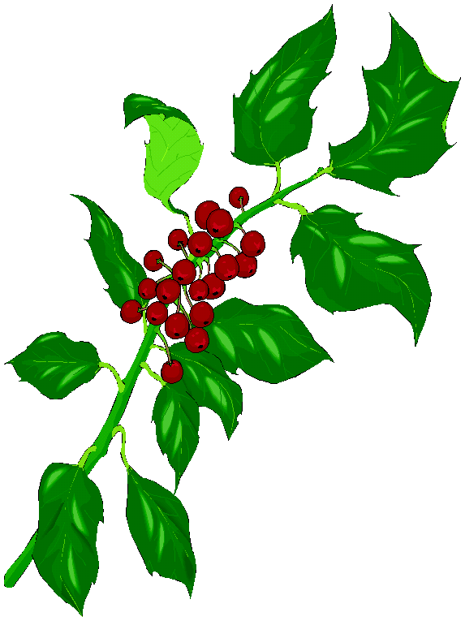

In the weeks leading up to Christmas, people hang decorations in their homes. These decorations are for example made of coloured paper. People also hang greenery around the house, such as oaks and ivy. Red and green are the traditional colours of Christmas. Green represents the continuance of life through the winter and the belief in eternal life through Jesus. Red symbolizes the blood that dropped from Jesus at his crucifixion.

Christmas cards 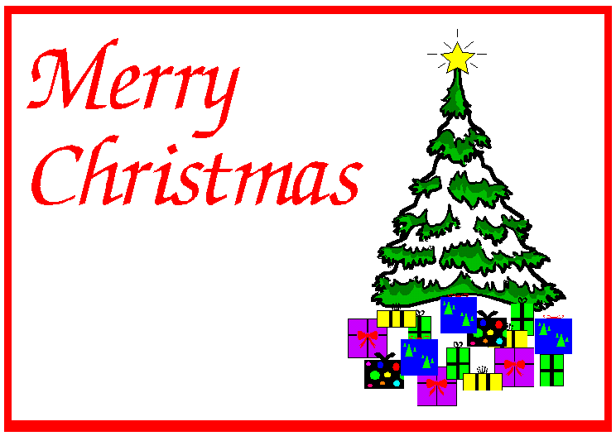

In England the first Christmas card was posted in the 1843. A man named John Calcott Horsely printed the first Christmas card. Over a billion Christmas cards are now sent every year in the United Kingdom. Last year 58 million Christmas cards were sent in Sweden. In England there are different kinds of cards. The traditional ones are religious with a scene of Mary and Joseph or a white dove.
The most common card is a picture of a winter scene with a Christmas tree.

Christmas Day 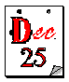

England doesn’t celebrate Christmas at the same time as we do here in Sweden. They celebrate on Christmas day, on the 25th of December.
Christmas day is the opening of presents and many families go to church where there are Christmas services. Christmas Day is a very exciting day for young children. It is the time when Father Christmas comes. The children leave out pies and brandy for Father Christmas, and a carrot for the reindeers. They hang their stockings or bags on the chimney ready for Father Christmas, who will hopefully fill them up with presents, if the children have been good. On Christmas day Father Christmas takes all of the toys into his sleigh and rides across the sky with his twelve reindeers. The most famous of the reindeers is Rudolf. He is always in the front and leads the way with his red shining nose.

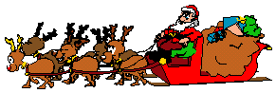

Another traditional thing takes place in the afternoon on Christmas day. It’s the Queen's Christmas speech to the nation. The speech is broadcasted on radio and television. In Sweden we have Donald Duck who is almost a thirty-year-old tradition. Every year Donald Duck and his friends send Christmas cards to Jiminy Cricket. The traditional characters are Mickey Mouse, Cinderella and Snow White with the seven dwarves and many more. The man who presents these films is called Arne Weise who does this every year at the same time in the same channel.

Christmas dinner 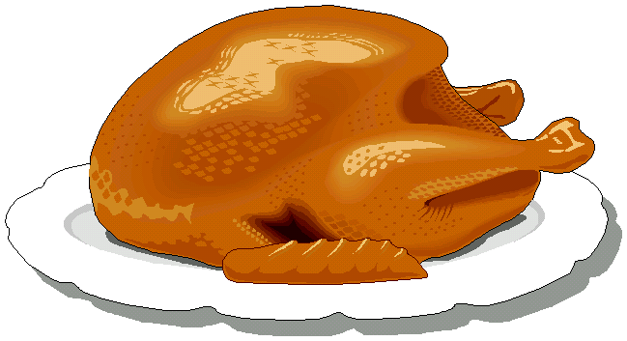

A traditional British Christmas dinner consists of turkey, vegetables, stuffing, cranberry sauce and gravy. A Christmas pudding is a brown pudding with raisins, nuts and cherries. It is served with custard or brandy butter. Sometimes you put silver coins in the pudding. A silver coin brings good fortune to the person who is lucky enough to find it when the pudding is cut.

Boxing Day

The day after Christmas is known in Britain as Boxing Day. This day you give a box of money or food to the people who have served you all year. It could be the deliveryman, the milkman, postman, dustman and other servicemen. Another traditional on this day is fox hunting. Horse riders dressed in red and white riding gear with a pack of hounds chase foxes through the countryside. This 'sport' is slowly dying out because the support for the fox is reducing.

Christmas Crackers 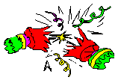
A London baker invented the cracker in 1846
These are very popular during many meals over the Christmas period. A Christmas cracker is a coloured paper tube, which is twisted at both ends. Inside the cracker there is a banger and when two people pull it, the cracker snaps in half with a bang. Inside the cracker there is a tissue paper hat, a joke or a little trinket.

Christmas Carols 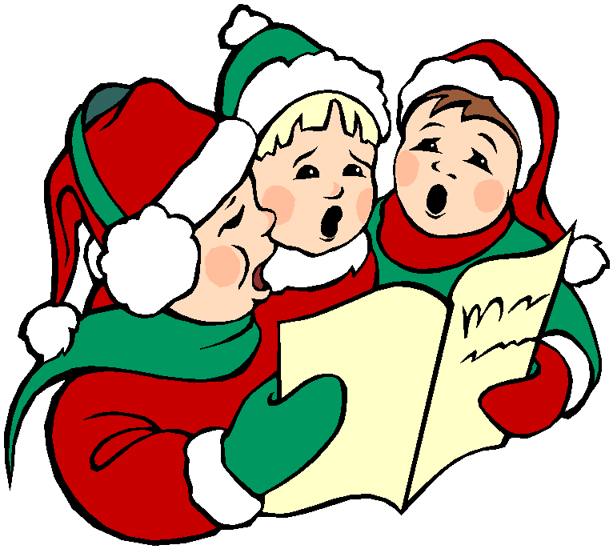
The Christmas in England also contains Christmas songs.
The songs are known as carols and they are about when Jesus was born.
Some people go from house to house, singing carols and collecting money for charity. In Sweden there are arrangements in church with different ceremonies where they sing the traditional Christmas songs.

Christmas cake
Together with tea the people in England usually eat a special Christmas cake.
It is a fruitcake with marzipan, icing and sugar frosting.

The differences and similarities

The Swedish Christmas is a little bit different than the English one. In Sweden the day you get your presents and you eat the traditional food, this day is called Christmas Eve. On Christmas Eve you gather your family and relatives and you eat a traditional Swedish Christmas table. On the table you have all the delicious food, and at this time people often get up in weight because they eat too much. One thing that is put on every Swedish Christmas table is the Christmas ham. Its usually boiled and it tastes very good if I may say so. In Sweden we have a special drink.
It’s a soda, which is called “julmust” In my opinion it has a very good taste.
During the Christmas holiday the church have Christmas services and it is very common that families go there and listen to the traditional Christmas songs.

My own thoughts about Christmas

I like Christmas very much because it’s nice to gather my family you eat together; you watch Donald Duck and his friends. It’s the same characters every year, but I can’t miss it, it’s a tradition to see Arne Weise. Christmas is a very calm and friendly tradition, after all the stress about what to buy for Christmas presents for everyone. Before Christmas you have so much things to do in school, and finally when the Christmas holiday comes its very nice to slow down and just enjoy things.

List of references

Internet:
www.californiamall.com/holidaytraditions-england.htm
www.posten.se

Talks:
With my parents and host families in England during my stays there.

