St. Louis

Missouri

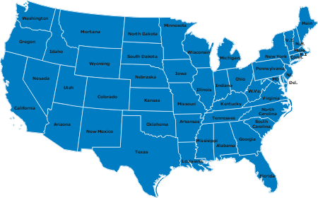

By: Lisa 9B
There are 50 states in the States. That’s why there are 50 stars on the American flag. I have been in one of the 50 states, in St. Louis, Missouri. It’s not a big city in the States but it’s bigger then Stockholm which is the capital city of Sweden. St. Louis became St. Louis in 1764.

The flag of United states.

There are some things that you can see in St. Louis like the botanical garden which is a big garden where you can see things like the Japanese and Chinese gardens. If you don’t like gardens you shouldn’t go there, but there are other places like Forest Park which is a great big park. There are a lot of things to do there like playing golf on Forest Park golf club, going to the Zoo and see some animals, taking a walk or bicycle around for hours. Before you get to Forest Park there are a lot of old brick houses, which are nice to look at. The ting that most people know about is the Mississippi River, which flows through St. Louis.


On April 6 this year the president of the USA, George W Bush was in St. Louis to speak. He also went to the first game of the year with the St. Louis Cardinals, which is a baseball team. They play in Bush Stadium.
The Baseball team in St. Louis. The Mississippi River.


The first thing you see when you get to the States is that people are fatter than in Sweden. That is because of all the fat food that people eat. When I landed at the airport in St. Louis everyone or almost everyone was eating a hamburger or a pizza. If you can’t see it in town you definitely see it in the stores. There are pants up to a size with waist 48 and with 29 in length. Something else that makes people fatter is that they don’t walk or exercise at all and drink a lot of soft drinks. Most people take the car everywhere because the buses don’t go very often.
Mc Donald’s and BurgerKing are 2 of the popular places to eat in St. Louis.

There are a lot of stores. If you drive up Manchester road you have stores the whole way and all over the place. There are even big gallerias with a lot of stores in them at a lot of places. The gallerias are much bigger then NK or Åhlens here in Stockholm. In the stores and places where you meet other people you realize how friendly and polite everyone is. They say hello and ask questions, people don’t do that in Stockholm very often. If you walk into someone or they walk into you they say excuse me. This never or almost never happens in Stockholm.

Some families go to church every Sunday. Before you had black clothes on, now you can have other colors as well. If a couple would want to get married in Sweden you would do it in church but in St. Louis you can get a priest to come and you can marry in the garden or where you want.
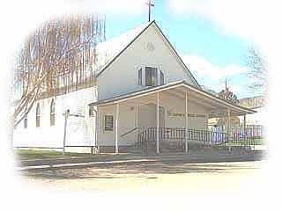
Some families who believe in God, say grace before dinner. There are not many families who do that in Sweden. When you aren’t used to it, it’s easy to forget, but for some people it’s very important to say grace “ Thank you Father for this food, bless it to Thy use and us to Thy service, and help us to be mindful of needs of others, Amen! “
A church in St. Louis.

The houses are more different than in Sweden. In the States you can see a couple of nice pretty houses and one minute later you drive past an area with small and not renovated houses, that you can’t imagine that anyone would live in. The rich people have great big houses with big gardens. Some of the rich people have someone to come over and fix the garden and clean the house. People move around a lot as well, like where I stayed, there were three houses of nine on the market.

Even children can see the difference in schools. The teachers are stricter in St. Louis than in Stockholm. If you talk with your friend during a lesson or have forgot your homework, you might have to stay after class and write, “I will never talk during class again” 100 times. In Sweden when you forget your homework some teachers don’t care, but in the States they care much more and the punishments can be hard. If that’s not enough, children get homework already in 1 grade of school. There are private schools in the States but it costs a lot of money to have your children there. In Sweden you don’t have to pay or at least not as much, like Kunskapsskolan.

A school in St. Louis.

On TV you can see the difference as well. In Sweden we have svt 1 and svt 2 where there aren’t any advertisements. In the States there are a lot of advertisements. If you see a movie on TV you will get the first 20 minutes to get you interested then there will be advertisements every 8-10 minutes.

