

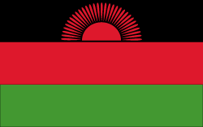
Climate
Malawi lies near the equator therefore it a climate where the temperatures are very high and also greatly influenced by the altitude of the lakes. The dry months are usually during the winter months, between May and October. At low altitudes, near rivers like, Shire River valley, temperatures can rise up to 37*C in the shade, during the hotter months of the year. July has around 22*C at the maximum, and 11*C at the minimum.
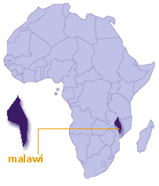
Public Holidays 1st of January, its new years day.✓ 3 of March it's Martry’s Day.✓ March/April Easter.✓ May 14, Kamuzu day.✓ July 6th, republic day.✓ October 17, mothers’ day.✓ December 21, National tree planting day.✓ December 25/26, Christmas.✓ If a holiday is on a Saturday or Sunday, the following Monday will also be free.

Health
It’s good if the visitor’s take prophylactic’s against malaria. You don’t need to take shots against smallpox, cholera, or yellow fever.
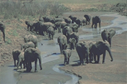
It’s recommended to bring a mosquito repellent if you are going camping, you should also bring mosquito nets. This is especially recommended if you are going camping during the summer months.
Even though Lake Malawi does not have bilharzias, it’s not recommended to swim in Stillwater, pools, and ponds, or in the rivers below plateaux. Nor should u use the water of Lake Malawi as drinking water, unless you have boiled it first.
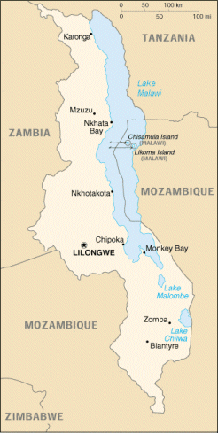
Airports
Most international flights land at Lilongwe, Malawi's capital, but several flights, especially those from Johannesburg and Harare, land at the business centre of Blantyre in the south.

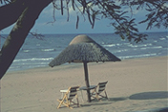

Wildlife
Malawi’s nine Wildlife Reserves offer true unspoilt wilderness. Experience the thrill of safaris as they used to be, staying in just a handful of exclusive lodges. The animals they have here are: lions and leopards; elephants and hippos; antelope and rhino. And the best bird life in the region.

People
Known as the Warm Heart of Africa, Malawi has deserved reputation for the friendliness of its people. Wherever you go you will receive a welcome which is rare anywhere else in the world. This is a land of smiles, of great friendship.

Souvenirs
There are attractive shops and galleries specialising in arts and crafts of Malawi in both Lilongwe and Blantyre. Central African's galleries in Blantyre and Lilongwe are the biggest with an excellent antiquarian map, print and book section. La Caverna's galleries in Limbe near the Shire Highlands Hotel, and Lilongwe have a good selection of original paintings and carvings by Malawian artists, as does the Mede gallery in Lilongwe's New City Centre. Paragon ceramics shops in both Dedza and Nkhotakota are well worth the short detours off the main north-south roads. There are many curio shops throughout Malawi's towns and cities, even by country roadsides, selling basketry and carved wood, useful and decorative, and, after the expected haggling, very inexpensive.
