Introduction

I have been writing about NASA´s Pathfinder mission, which is a part of their ongoing Mars exploration project. The reason I choosed to write about it was a newspaper article on the subject. I found the article interesting and decided I wanted to know more.

Table of contents

____________________________________________________________________page___

Introduction and table of contents.................................................................................1

Pathfinder - a mission to Mars....................................................................................... 2
The arrival to Mars............................................................................................................2
Expectations...................................................................................................................... 2-3
Surprises............................................................................................................................ 3-4
Questions.......................................................................................................................... 4-5

Conclusion........................................................................................................................6

Pathfinder - a mission to Mars

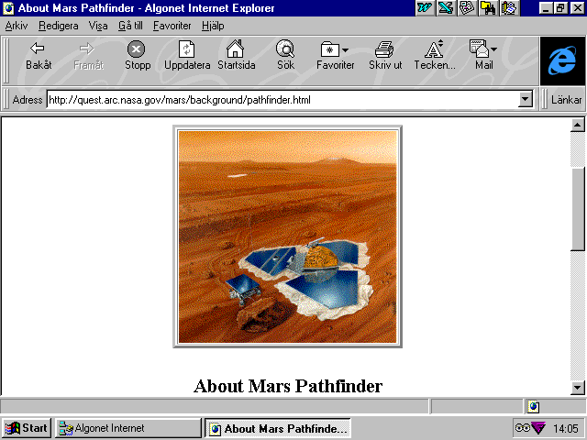
We have waited a long time for an emissary from Earth to descend on to red plains Mars. The last time it happened, Gerald Ford was the president of the United States, moviegoers were flocking to see an
actor named Sylvester Stallone in Rocky, and for some unknown reason people were listening to disco.

The picture below shows the rover named Sojourner. The rover weighs less than 14 kg and among its payload is the Alpha Proton X-ray Spectrometer deployment mecha-
nism and four cameras. The rover is being controlled remotely from Earth.

The arrival to Mars
After 21 years, the waiting is over. On the fourth of July this year (1997) NASA’s Mars Pathfinder had successfully travelled 309 million miles through space, endured a fiery entry into the martian atmosphere, survived at least 16 bounces, and landed on
target and within one second of its estimated time of arrival.
Within hours of its touchdown,
Pathfinder beamed back several dozen images of the rocky martian surface. By day three, after engieers at NASA had overcome

several minor technical glitches, the
microwave-oven-sized Sojourner
rover was creeping across the martian surface and examining
rocks and soil with its Alpha Proton X-ray Spectrometer. Two weeks after Pathfinder landed, it
was already clear that the mission
was going to be a spectacular success.
Pathfinder fits perfect in NASA’s new policy ; ”faster, better, cheaper.” The total cost of the mission is 280 million dollars, which is very low in comparison to other NASA projects. The Pathfinder project will cost the American taxpayers about $2 each spread over four years.

Expectations
Scientists are hoping Pathfinder will help them figure out why
Mars’s climate turned out so different from Earth’s. Today, Mars is much colder and drier than Earth. Chilly temperatures and low
atmospheric pressure prevent water from existing as a liquid on the surface of Mars. But images taken

Facts
Mars
Mass | 0.11 times Earth’s
Moons | Phobos, Diemos
Diameter | 6794 km
Day | 24h 37 min
Year | 1.88 Earthyears
Density | 3.9

This colour image shows the Sojourner rover’s Alpha Proton X-ray Spectrometer (APXS) deployed against the rock called ”Moe” (the pathfinder scientists has named every rock they have examined) on the morning of September 10. The rock behind the rover is ”Half Dome” wich was previously measured by the APXS.
in the 1970s by the twin Viking orbiters clearly show channels that
were carved by running water 4.5 to 3.6 billion years ago, just at the time life was establishing a foothold on Earth.
If Mars once had running water, it must have had a thicker atmosphere and a warmer climate, a climate that may have nurtured life.
But even after most of the atmosphere withered away and the surface dried up, Mars suffered occasional catastrophic floods. Scientists chose Pathfinder to land in an area called Ares Vallis. This was because the Viking orbiter photos showed that the area was located in the mouth of an ancient flood plain. Sceintist presume that floods originating from the martian highlands would carry a lot of rocks into Ares Vallis. By examining rocks from different parts of Mars, scientists could reconstruct the past few billion years of martian history.
Moments after Pathfinder’s first images reached jubilant scientists and engineers on Earth, even the untrained eye could tell that the Ares Vallis site more than lived up to the expectation. Scientists were delighted by the diversity of rock
sizes and types. The landing site was surrounded by interesting
locations. Less than one mile to the
west there were two 1000-foot-

high mountains ; the Twin Peaks
and 1.4 miles to the south there was an impact crater. On top of that scientists could see bare rocks that were left uncontaminated by Mars’s reddish iron-oxide dust. The two Viking landing sites seem outright dull in comparison.

This picture shows a martian sunset.

Surprises
To the surprise of scientists, the first rock examined by Sojourner, was rich in quartz. This makes the rock more similar to rocks here on earth than to any of the 12 known

This is a picture of the rock known as ”Chimp”.
It was taken by the Sojourner rover’s right front camera on September 17.

The Pathfinder team stares intensely at Pathfinders first image from Mars.

This wide picture is assembled from hundreds of indivi-
dual images.

martian meteorites. To form quartz, a rock must be heated and reheated many times. The conclusion that scientists draw
from this is that Mars probably has been more active than once thought
Images taken by the Pathfinder
show that scientists were right about the flood. The pictures shows that blocks of rocks are angled and stacked in the same direction. Evidence of layered sedimentation can bee seen in both nearby rocks and the Twin Peaks. What may bee salty residue left by evaporating water lies right next to the lander. The rampaging flood waters must have covered hundreds of square miles, extended hundreds of feet deep, flowed for thousands of miles, and travelled roughly 159 miles per hour.

Questions
For the moment Pathfinder’s data and images raises more questions than answers. Where did all the water come from? Where did it go?

Was liquid water stable on the surface when the deluge occurred 1
to 3 billion years ago? Did an asteroid or comet impact trigger a sudden release of groundwater, or was the flood triggered by something else? Was there one catastrophic flood or was there several floods? The answers to these questions will provide clues as to what happened to the martian climate, and whether and when the
planets surface could have supported life.
On Earth, wherever there is water, there is likely to be life. Is this pattern true for Mars also? Pathfinder won’t be able to answer this question directly because Sojourner’s imager and spectrometer are not sensitive enough to detect the chemical signatures of life, such as those possibly found in the martian meteorite ALH84001. But just as the Viking missions paved the way for Pathfinder, Pathfinder is blazing the trail for an armada of NASA

probes which is going to the Red Planet. An orbiter called Surveyor arrived to Mars in September and is now in an orbit around Mars. It will start its 2-year mapping project in March 1998. Surveyor will be followed by a series of successively more ambitious landers and orbiters, which will culminate in a mission in 2005. This mission will bring back samples of rocks to Earth.
Ultimately, a human expedition will likely be required to determine
if life once existed on Mars, or if life currently is existing beneath the

barren, desertlike surface. People will have to go to set up laboratories, so human beings are absolutely crucial. But not yet.
While we wait for future missions, including a human expedition sometime in the first two decades of the next century, we can enjoy and learn from the Pathfinder images and data that will bee pouring over us.
This enhanced colour image mosaic of the Rock Garden area west of the lander was made using images acquired on the morning of September 19 by the IMP camera as part of the Super Pan data set.

Conclusion

Through all the year I have had english in school I have never done anything like this before. We have written smaller projects, but not anything as large as this. I feel that I have learned a lot from working with the project (especially new words) and that’s probably because its easier to learn if you are working on something that interests you. You feel much more motivated. So it has been rewarding working on this project.

