D-Day – the Longest Day
D-Day was the culmination of over two years of planning by the British and American warleaders. In an operation that involved the formation of the largest invasion fleet in the history of mankind, the massed allied armies successfully landed in Normandy, punching a giant hole in the seemingly indestructible walls of Hitler’s “Fortress Europe”.
Supported by troops dropped from the air and massive bombing raids, the armies secured the beachheads by the evening of the first day. With this began Operation Overlord – the hard and bloody advance that ultimately led to Berlin and towards the victory.
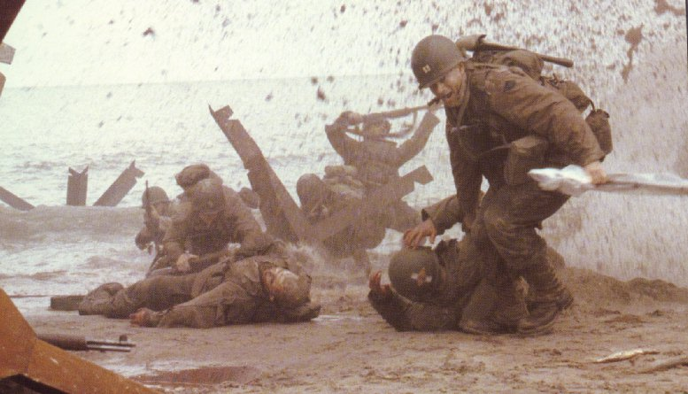
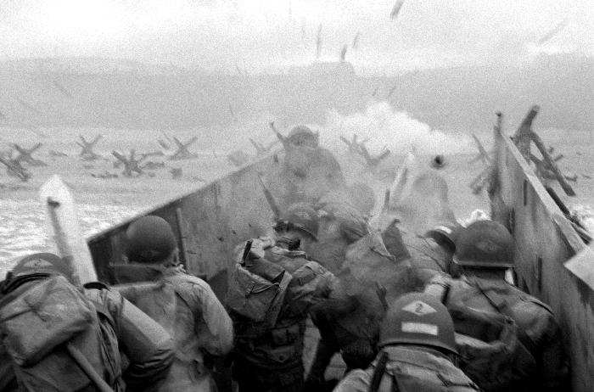
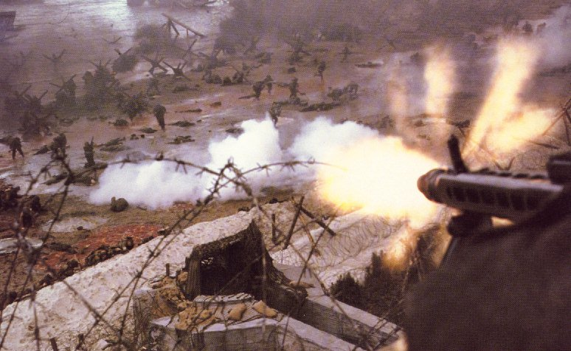
The beach seen from a soldier’s point of view, from his landing craft.
The beach seen from a german bunkersoldier’s point of view.
A soldier struggling to get his friend onto the beach.

N.B. All the pictures are from the movie ”Saving Private Ryan”.

At 4.30 a.m. the 6th of June 1944, the first Allied troops landed in Normandy. The allied troops had planned this invasion for a long time. It had even been postponed two days while a storm had broken lose over the English Channel the 4th and 5th.

The highcommander in charge was the American general Dwight D. Eisenhower. The reasons for the invasion were many, among others that the Russians moved towards Berlin and the allied feared that they would get the hands on all of Europe. Another reason was that the allied found this time be the right to crush the Germans that were on the verge of collapse.
The 50-mile stretch of France, called Normandy, was divided into five beaches, each one was assigned to one of the membercountry of the allied axis:
- Utah & Omaha beach – American.
- Sword & Goldbeach – English.
- Junobeach – Canadian.
By midnight June 6th, the Allies had landed some 155,000 men in Normandy (including some 26,000 by air), with more than 1,000 veichles and heavy guns. They took around 12,000 casualties – the greater proportion on “Bloody Omaha”. German losses on D-Day have been estimated at 6,000. On some beaches the odds being killed were 1:2.
Wordlist:
amphibious amfibisk (mil. vattenburna trupper) coincide sammanfalla
casualty förluster i döda, olycksoffer staging area uppsamlings plats
postpone skjuta upp, senarelägga pillbox mil. betongvärn

