Australia
Boomerangs

The boomerang is a long ranged, curved throwing stick used chiefly by the aborigines of Australia for hunting and warfare, and was made of hard wood. The aborigines used three kinds of boomerangs and many kinds of boomerang-shaped clubs.

The returning boomerang

is light, thin, and well balanced, and are normally 12-30 inches
(30-75 centimetres) in length, and up to 12 ounces (about 340 grams) in weight.
Returning boomerangs were used only in eastern and western Australia as playthings, in tournament competition, and by hunters for driving flocks of birds into nets.
The nonreturning boomerang also called ”weaponboomerang” is longer, straighter, and heavier than the returning. With it animals were hunted and killed, while in warfare it caused serious injuries and death. One type has a picklike hook, like a nail at one end. Boomerang-shaped, nonreturning weapons were used by the ancient Egyptians, by Indians of California and Arizona, and in southern India for killing birds, rabbits, and other small animals. It could be as max 2 metres high. An Aborgine could bring down an enemy at a distance of 152 metres.
And so there was a type that the aborgines used for work, like digging holes.
Some Boomerang types: But there are many hundreds of types.

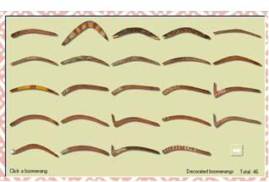
2000-05-25 Av: Karl-Johan Strömqvist

